**Introduction to Azure PIM Project**

**Project Overview**

This project covers the end-to-end setup and configuration of Microsoft Entra Privileged Identity Management (PIM) in an Azure environment. PIM is a security feature within Microsoft Entra ID (formerly Azure AD) that enables Just-in-Time (JIT) access, approval workflows, time-bound role assignments, and access auditing for highly privileged accounts.

The purpose is to reduce the risk of excessive, unnecessary, or misused access permissions and ensure tighter control over administrative actions within the organization.

**Goals of the Project**

* Enable Just-In-Time (JIT) activation for highly privileged roles
* Configure MFA, approval, ticketing, and time-limit settings for elevated access
* Set up and test Privileged Access Groups
* Configure and test Break-Glass accounts for emergency use
* Perform Access Reviews and analyze audit logs
* Document the entire implementation with screenshots

**Accounts Used**

|  |  |  |
| --- | --- | --- |
| Account | Role | Purpose |
| GunishBakshi@Bakshi2004.onmicrosoft.com | Global Administrator | Main account used to configure and manage PIM |
| Admin@Bakshi2004.onmicrosoft.com | Eligible Global  Administrator | The account used to send requests and to have the main control of the System. |
| reviewer@Bakshi2004.onmicrosoft.com | Privileged Role Administrator | Used to approve JIT access requests |
| breakglass@Bakshi2004.onmicrosoft.com | Permanent Global Administrator | Emergency break-glass account with non-expiring access |

**Tools and Services Required**

* Microsoft Entra ID (Azure AD)
* Microsoft Entra PIM (Privileged Identity Management)
* Identity Governance & Access Reviews
* Azure Portal
* Microsoft Word for documentation

**Project Methodology**

This implementation is structured into multiple steps. Each step is documented separately and includes:

* Configuration instructions
* Screenshots (with placeholders)
* Descriptions of actions taken
* Final validation results

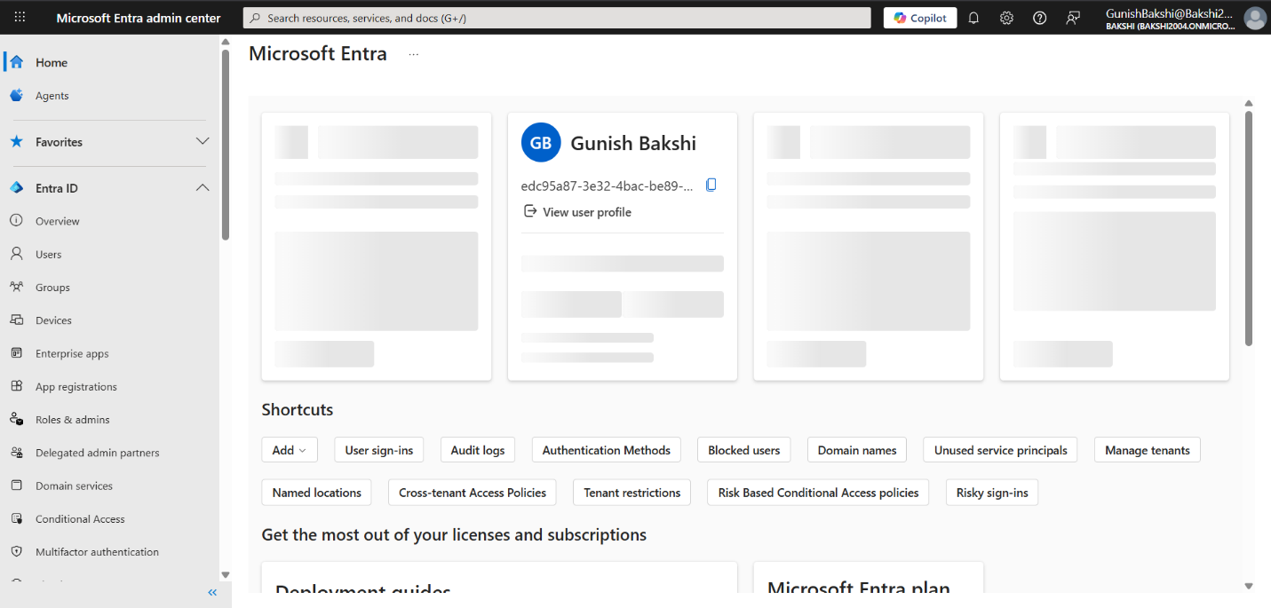

* Microsoft Entra

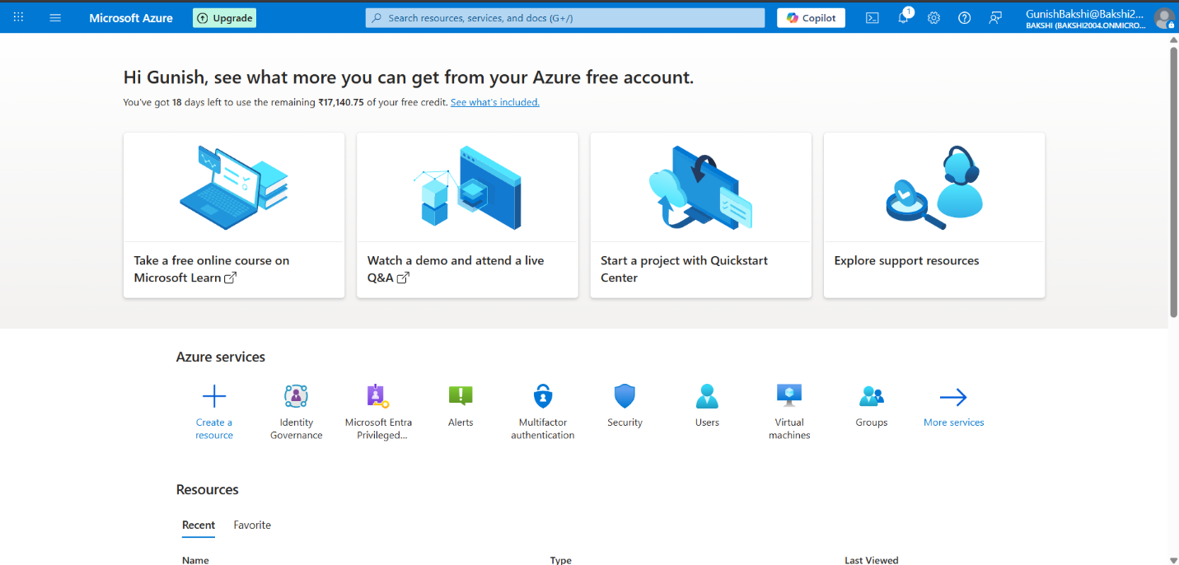

* **Azure Portal**